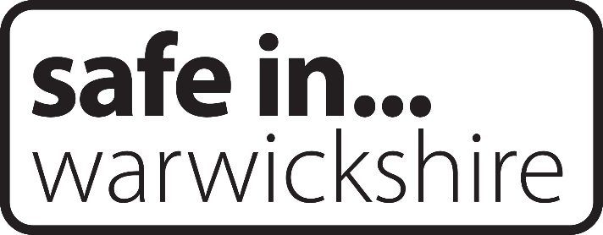
WARWICKSHIRE COMMUNITY SAFETY
INFORMATION SHARING PROTOCOL

JOINT APPROACH TO MAKE WARWICKSHIRE A PLACE WHERE PEOPLE
FEEL SAFE TO LIVE, WORK, AND VISIT

COMMISSIONED BY THE SAFER WARWICKSHIRE PARTNERSHIP BOARD
September 2019
Updated July 2023

Contents

Page 3 Section 1 Introduction
Page 4 Section 2 Purpose of Information Sharing
Page 5 Section 3 Who Will Be Sharing Information?
Page 6 Section 4 What Is to Be Shared?
Page 7 Section 5 Fairness and Transparency
Page 8 Section 6 Arrangements for Data Sharing Within Multiagency Meetings
Page 9 Section 7 Process for Data Sharing Outside Meetings
Page 10 Section 8 Nominated Representatives
Section 9 Data Controller Responsibilities
Section 10 Agents and Sub-Contractors
Section 11 Complaints
Page 11 Section 12 Non-Compliance and Partner Disagreement
Section 13 Data Breaches
Page 12 Section 14 Retention and Disposal
Section 15 Access to Information and Mutual Assistance
Page 13 Section 16 Monitoring and Review
Section 17 Indemnity
Page 14 Section 18 Change History
Section 19 Effective Date

Page 15 Appendix 1 Legal Basis for Sharing Information
Page 16 Appendix 2 Do We Need This Information?
Page 17 Appendix 2a Flowchart of when and how to share information
Page 18/19 Appendix 3 Generic confidentiality declaration sign-in sheet
Page 20 Appendices 4-9 Specific confidentiality declarations / data sharing agreements
(One per setting in which data needs to be shared and a specific agreement is used)
Page 28 Appendix 10 Request from external agencies to the Police for information
Page 30 Appendix 11 Request from the Police to external agencies for information
Page 34 Appendix 12 Safer Warwickshire Partnership Board Signatures
Page 37-41 Appendix 13 Additional Signatures

1. Introduction

1.1 The Safer Warwickshire Partnership Board aims to create safer communities through the reduction of crime and the promotion of safety.

1.2 The Board is responsible for putting in place an information sharing protocol to facilitate information sharing between responsible authorities for community safety in Warwickshire as required by the Crime and Disorder (Formulation and Implementation of Strategy) Regulations 2007 (Regulation 4). This should be agreed by all responsible authorities, statutory agencies
and other groups providing community safety in the county (“Partner agencies”).

1.3 Responsible authorities as detailed by the Crime and Disorder Act 1998:
- The council for the area (County and District/Borough)
- Chief Officer of Police
- Probation Service
- Fire and Rescue Authority
- Integrated Care Board

1.4 The purpose of this information sharing protocol is to facilitate the secure sharing of information, including sensitive or confidential information, between partner agencies in Warwickshire; govern the secure use and management of information and enable Partner agencies to meet their legislative obligations. Information sharing agreements such as this one have no statutory basis and do not substitute for appropriate controls within individual organisations when requesting, disclosing, and transmitting personal data. They do, however, demonstrate cooperation between partners and the intent to share information securely and effectively.

1.5 This information sharing protocol provides specific details for information sharing within a community safety context. As well as setting out the general principles to be followed when sharing community safety information, it includes (as appendices) confidentiality declarations or where appropriate “Data Sharing Agreements” for each specific multiagency meeting where data needs to be shared. Additional appendices can be added as new groups or scenarios in which information needs to be shared emerge.

1.6 The settings currently covered in this protocol are as follows:

- Using the generic confidentiality declaration (see appendix 3):
- Community Impact Operational Groups
- Vulnerability meetings
- Partnership Problem Solving meetings
- Domestic Homicide Review Panels
- Hate Crime meetings
- ASB, Youth, Victim, Perpetrator, and other Case Management meetings
- Multi Agency Public Protection Arrangements (MAPPA) (see Appendix 4)
- Multi Agency Risk Assessment Conferences (MARAC) (see Appendix 5)
- Integrated Offender Management (IOM) Multi Agency Case Conferences
(See Appendix 6)
- Early Help Locality Panels (see Appendix 7)
- Channel Panel (see Appendix 8)
- Serious and Organised Crime Joint Action Group (SOCJAG) (see Appendix 9)
- Community Safety Partnership meetings

1.7 The protocol has been updated to reflect the General Data Protection Regulation (“GDPR”) and Data Protection Act 2018.
2. Purpose of Information Sharing

2.1 The purpose of this protocol is to facilitate the lawful exchange of information, other than anonymised information, in order to comply with the statutory duty placed on the responsible authorities (as at 1.3 above) to work together to formulate and implement strategies for reducing crime and disorder (including anti-social behaviour and other behaviour); combatting the misuse of drugs, alcohol and other substances; reducing re-offending; preventing people from becoming involved in serious violence, and reducing instances of serious violence.

2.2 This protocol will also extend to co-operating organisations and any other agency or organisation which is a signatory to the document.

2.3 Information sharing is the cornerstone of delivering shared understanding of issues and arriving at holistic solutions. Effective delivery relies on good decision making and those decisions should be based on good information. The right information enables partners to carry out evidence-based, targeted community safety interventions and evaluate their impact. The improved outcomes of an intelligence led, problem solving approach to community safety can only be achieved when partners have access to relevant, robust, and up-to-date information from a broad range of sources.

2.4 Partners should also consider the likely effect of not sharing information, for example, harm to individuals, damage to their organisations’ reputation, a disconnect in partnership working and lack of understanding of problems.

3. Who Will Be Sharing Information?

3.1 Partners who are required to share information are named as the responsible authorities in the Crime and Disorder Act 1998, as amended. These are the council for the area (including County and District/Borough), Probation Service, Chief Officer of Police, Fire and Rescue Authority, and the Integrated Care Boards.

3.2 Persons or bodies may ‘co-operate’ in the exercise of responsible authorities’ functions, including sharing information. “Co-operating persons and bodies” include Parish Councils, School and College Governing bodies, Registered Social Landlords, and agencies appropriate to the location or circumstances.

3.3 Various other bodies may ‘participate’ in the exercise of responsible authorities’ functions. “Participating persons and bodies” may also be asked to share information.

3.4 Wider partners may also be required to share information in specific circumstances. These could include schools, other health agencies and voluntary sector organisations.

3.5 Collectively, these organisations shall be referred to as “Partner agencies”. This protocol is approved by the Safer Warwickshire Partnership Board. Member organisations of this Board sign up to the principles of the protocol by virtue of their membership. Other partners can formally sign up to the protocol. To do so, or to check if an agency has signed up to the protocol, please email communitysafety@warwickshire.gov.uk.

3.6 Where an agency is not signed up to the protocol, but a partner/partners wish to share Shared Personal Data with them, extra care should be taken to ensure they understand how sensitive information they see should be shared and handled by providing a specific instruction and handling arrangement and ensuring the agency representatives sign a confidentiality agreement to confirm that they understand their responsibilities. A generic agreement for this can be found at Appendix 3.

4. What Is ‘To Be Shared’? (Referred to as “Shared Personal Data”)

4.1 The ‘Delivering Safer Communities’ guidance and the Crime and Disorder Act 1998 place a duty upon relevant authorities to share information. Additionally, Partner agencies have express and/or implied powers to share information as set out in legislation. (See Appendix 1 for a list of legislation. Note that this is not an exhaustive list)

4.2 Shared Personal Data will usually include information about the nature of the problem and, where relevant, personal data such as names, addresses and dates of birth of offenders, victims, or witnesses.

4.3 Most of the Shared Personal Data will also include sensitive/special category/criminal offence personal data as defined in data protection legislation. Sharing of this type of sensitive information is allowed in lawful and appropriate circumstances. Any sharing of personal data including sensitive data known as special category data or criminal offence data must be undertaken in accordance with GDPR and Data Protection Act 2018.

4.4 In order to share appropriate information between partners there must be a lawful, defined, and justifiable purpose(s) which supports the effective delivery of a policy or service that respects people’s expectations about the privacy and confidentiality of their personal information but also considers the consequences of a failure to act. This agreement is supplemented by a number of questions, included at Appendix 2, designed to ‘walk’ Managers/Designated Persons and other specialist support through a process to assess the impact and appropriateness of information sharing.

4.5 ‘Signatories’ to this protocol understand that Shared Personal Data will be shared at multi-agency meetings (see Section 6). For example, there may be meetings between members of staff from different agencies sharing information about a common case to build a foundation of accurate knowledge and evidence, to minimise the risk of harm to the community, whilst allowing proper management of the case. As well as meetings, the protocol also covers other forms of information exchange such as the ECINS case management system. The intention of this protocol is to cover all such information sharing provided the safeguards described within it are followed.

4.6 If any Shared Personal Data relates to an ongoing investigation or prosecution by any of the agencies then consultation must take place with the investigating officer and Crown Prosecution Service as the matter will be sub-judice. This will ensure that disclosure will not adversely prejudice the outcome of the matter.

4.7 Special care should be taken when considering the sharing of information that could constitute profiling, particularly of children. A legal justification must be available before any sensitive information is shared.

5. Fairness and Transparency

5.1 In the interests of fairness and transparency, partners agree to the following principles:

  - All information will be shared in a lawful manner. Any Shared Personal Data, including special category data and criminal offence data will be shared lawfully and in accordance with the data protection principles, GDPR and Data Protection Act 2018.

  - Data protection principles require individuals to make sure personal information is:
- used fairly, lawfully, and transparently
- used for specified, explicit purposes
- used in a way that is adequate, relevant, and limited to only what is necessary
- accurate and, where necessary, kept up to date
- kept for no longer than is necessary
- handled in a way that ensures appropriate security, including protection against unlawful or unauthorised processing, access, loss, destruction, or damage.

  - Where possible, anonymised information will be used.

  - Where appropriate and where safe and possible, individuals will be requested to provide their ‘consent to share’ with appropriate partner agencies. This consent will be secured in accordance with the standards set out in the new General Data Protection Regulation.

5.6 Where it is not appropriate to seek informed consent, personalised information will only be shared if there is another lawful basis to share it under data protection legislation or where relevant one of the exemptions in the Data Protection Act 2018 (e.g., Crime and Taxation) applies. The questions listed at Appendix 2 help to assess the impact on service users of decisions relating to information sharing.

5.7 Data Protection Impact Assessments (“DPIA’s”) will be undertaken for each purpose or scenario in which different types of personal data will be shared, including new purposes or scenarios as they arise. It is recommended that Partner agencies shall be responsible for the completion and updating of the DPIA’s for each meeting they deliver.

5.8 Each organisation will have a nominated Data Protection Officer to oversee their information sharing responsibilities and will be correctly registered with the Information Commissioner to share appropriate information.

5.9 Partner agencies shall be responsible for updating their privacy notices to provide details of information sharing and to inform individuals about the processing of their data.

6. Arrangements for Data Sharing Within Multi-Agency Meetings

6.1 Using the definitions in 6.4 of this agreement the chair of each meeting should designate the level of confidentiality appropriate to the information being shared at the outset and, where relevant, provide a confidentiality declaration sign-in sheet (Appendix 3) which states the data sharing requirements relevant to the meeting. If used, the chair should securely retain a copy of this confidentiality declaration sign-in sheet.

6.2 The parties to this protocol understand that in keeping with government initiatives to invite a wider spectrum of society to assist the relevant authorities to implement the Crime and Disorder Act 1998, it is likely that there will be individuals present at certain meetings who are not representing an organisation which is a signatory to this protocol. To allow for this, the signing-in sheet should state that the signatory agrees to abide by all the terms of this protocol.

6.3 It is good practice to use the Government Security Classifications. These set out levels of confidentiality and appropriate security measures. These classifications are the method by which the originator of an asset (that is all material assets, i.e., papers, drawings, images, disks, and all forms of electronic data records) indicates to others the levels of protection required when handling the asset in question, in terms of its sensitivity, security, storage, movement both within the guidance and outside the originator’s own department or force and its ultimate method of disposal.

6.4 The levels of classification are:

OFFICIAL - all routine public sector business, operations, and services.

OFFICIAL – SENSITIVE - a limited subset of OFFICIAL information that could have more damaging consequences (for individuals, an organisation or government generally) if it were lost, stolen, or published in the media. In cases where there is a clear and justifiable requirement to share only on a need-to-know basis, the OFFICIAL–SENSITIVE classification should be used.

SECRET – Very sensitive information where compromise would directly threaten an individual’s life, liberty or safety or cause serious damage to the effectiveness or security of the UK.

TOP SECRET - Exceptionally sensitive information assets that directly support (or threaten) the national security of the UK or allies.

6.5 The chair of each multiagency meeting is responsible for ensuring the confidentiality declaration sign-in sheet is kept current and as far as they are able to, includes all legal requirements surrounding information sharing.

7. Process for Data Sharing Outside Meetings

7.1 This agreement has been formulated to facilitate the exchange of information between partners. It is, however, incumbent on all partners to recognise that any information shared must be justified on the merits of each case.

7.2 Information must be requested in a legally compliant manner, setting out the legal grounds for disclosure, for example if the Crime and Taxation exemption under the Data Protection Act (DPA) 2018 Schedule 2 Part 1 (2) is being relied on, then this should be formally set out and the specific details provided. Where relevant, including the use of information as evidence for prosecution, the Warwickshire Police access request forms (Appendices 10 and 11), or alternative official third-party subject access request form where required by other partners, must be used.

7.3 Partners sharing information should make clear who the information can be shared with in their Privacy Notice and Record of Processing Activity (ROPA). Information shared should only be used for the purpose requested by the requesting partner and should not be shared further without consent of the information owner unless there is a legal obligation or other lawful basis for doing so.

7.4 Any data should be shared and stored in accordance with the relevant legislation. In particular, where the data to be shared is personal, a secure transmission system should be used, such as secure email or courier or hosted on a secure system shared by partners. All Partner agencies must have appropriate technical and organisational measures in place, having regard to the nature and sensitivity of the information, to ensure information security. This will include monitoring and auditing procedures as well as the ability to respond to any failure to adhere to the data sharing agreement swiftly and effectively and to report and personal data breach.

7.5 Any information shared should only be kept as long as it is necessary and then confidentially destroyed by all signatories in accordance with any relevant data retention and disposal policies.

7.6 Appendix 2 gives a checklist to help ensure that data is lawfully shared.

8. Nominated Representatives

8.1 Each partner organisation shall have a Designated Officer who will facilitate data sharing under this protocol where issues arise.

8.2 Any disputes or disagreements between parties, including why one agency decides not to share information with another, shall be resolved by discussion between the Designated Officers, if at all possible, or between the heads of each agency.

9. Data Controller Responsibilities

9.1 Data Controllers must make appropriate notifications of any data breaches to the Information Commissioner in compliance with the General Data Protection Regulation and in accordance with any guidance issued by the Article 29 Working Party and the Information Commissioner’s Office. This notification should include details of the Data Protection Officer or nominated contact.

10. Agents and Sub-Contractors

10.1 Each partner organisation shall ensure its agents and sub-contractors comply with the provisions of the protocol.

11. Complaints

11.1 Each partner organisation will deal with the complaints in accordance with their own procedures, which will ensure that:
  - Service users are aware that they can complain and of how to go about it;
  - Complaints are acknowledged promptly in writing;
  - The complaint is investigated fairly and thoroughly;
  - Service users are given an appropriate written response;
  - If appropriate the appeals procedures are explained to the service-user.

11.2 If two or more partner organisations receive a complaint about the same matters, they should investigate and respond to the complaint jointly.

11.3 If a partner organisation receiving a complaint believes another partner organisation may be responsible, wholly, or partly, for the matters complained of it should notify the other organisation and the organisations should investigate and respond to the complaint jointly.

12. Non-Compliance and Partner Disagreement

12.1 In the event of a suspected failure within their organisation to comply with this agreement, partner organisations will ensure that an adequate investigation is carried out and recorded. If the partner organisation finds there has been a failure it will ensure that:
  - Necessary remedial action is taken promptly;
  - Service users affected by the failure are notified of it, the likely consequences, and any remedial action;
  - Partner organisations affected by the failure are notified of it, the likely consequences, and any remedial action.

12.2 If one partner organisation believes another has failed to comply with this agreement it should notify the other partner organisation in writing giving full details. The other partner organisation should then investigate the alleged failure. If it finds there was a failure, it should take the steps set out above. If it finds there was no failure it should notify the first partner organisation in writing giving its reasons.

12.3 Where it is clear that a partner organisation is not complying with this protocol, other partners may decide to stop sharing information until the issues are resolved.

12.4 More information about information sharing is available from the Information Commissioner. Go to https://ico.org.uk/

12.5 Partner organisations will make every effort to resolve disagreements between them about personal information use and sharing. However, they recognise that ultimately each organisation, as Data Controller, must exercise its own discretion in interpreting and applying this agreement and ensuring compliance with the data protection legislation.

12.6 Nominated representatives should be notified at an early stage of any suspected or alleged failures in compliance or partner disagreements relating to their organisation.

13. Data Breaches

13.1 A data breach is where there has been a breach of security leading to the accidental or unlawful destruction, loss, alteration, unauthorised disclosure of or access to personal data. Where there has been a data breach by or on behalf of a partner in respect of any Shared Personal Data, the partner agency where the data breach has occurred will inform all affected partners of the data breach immediately to enable them, where relevant, to meet their legal duty under GDPR to report personal data breaches within 72 hours.

13.2 The partner agency needs to take immediate action to recover the information, if safe to do so.

13.3 The partner agency where the breach has occurred shall conduct a full investigation of the breach and the findings of the investigation will be shared with the other partners and the Safer Warwickshire Partnership Board.

13.4 Partners need to formally record all data breaches in respect of personal data they are data controller in respect of, internally within their organisation and inform the Safer Warwickshire Partnership Board to ensure effective monitoring and reviews can take place.

14. Retention and Disposal

14.1 Partners must comply with their own agencies’ retention and disposal policies. These should cover both electronic and paper-based information.

15. Access to Information and Mutual Assistance

15.1 Partners must have in place policies to deal with people’s information rights under Freedom of Information (FOI) legislation, the General Data Protection Regulation (GDPR) and the Data Protection Act (DPA) 2018.

15.2 Each Partner agency shall assist the other in complying with all applicable requirements of the Data Protection Legislation. In particular, each party shall:
- consult with the other partners about any notices given to data subjects in relation to the Shared Personal Data;
- promptly inform the other partners about the receipt of any data subject access request;
- provide the other partners with reasonable assistance in complying with any data subject access request;
- not disclose or release any Shared Personal Data in response to a data subject access request without first consulting the other partner wherever possible;
- assist the other partner, in responding to any request from a data subject and in ensuring compliance with its obligations under the Data Protection Legislation with respect to security, breach notifications, impact assessments and consultations with supervisory authorities or regulators;
- notify the other partner without undue delay on becoming aware of any breach of the Data Protection Legislation;
- at the written direction of the Data Discloser, delete or return Shared Personal Data and copies thereof to the Data Discloser on termination of this agreement unless required by law to store the personal data;
- use compatible technology for the processing of Shared Personal Data to ensure that there is no lack of accuracy resulting from personal data transfers; and
- maintain complete and accurate records and information to demonstrate its compliance with this clause.

16. Monitoring and Review

16.1 The Safer Warwickshire Partnership Board will annually monitor and review the contents and implementation of this Information Sharing Protocol. The review will have regard to:
  - Changes in the relevant law and statutory or other government or national guidance;
  - Service user and staff opinions, concerns, and complaints;
  - Failures in compliance and disagreements between partner organisations;
  - Any other relevant information.

17. Indemnity

17.1 Each Partner shall indemnify the others against all liabilities, costs, expenses, damages and losses (including but not limited to any direct, indirect or consequential losses, loss of profit, loss of reputation and all interest, penalties and legal costs (calculated on a full indemnity basis) and all other reasonable professional costs and expenses) suffered or incurred by the indemnified partner arising out of or in connection with the breach of the Data Protection Legislation by the indemnifying partner, its employees or agents, provided that the indemnified partner gives to the indemnifier prompt notice of such claim, full information about the circumstances giving rise to it, reasonable assistance in dealing with the claim and sole authority to manage, defend and/or settle it.

18. Change History

Version | Amended by | Amended date | Summary of main changes
Draft v0.1 | Katie Whitehouse | 19/01/2018 | Reviewed entire protocol agreed in December 2013. Updated in light of changes to legislation, regulation, and policy.
Draft v0.2 | Katie Whitehouse | 20/02/2018 | Updated to include partner feedback received ahead of SWPB meeting.
Draft v0.3 | Alex Gloster | 29/08/2018 | Updated to include feedback from WCC Information Management Service.
Draft v0.4 | Alex Gloster | 10/01/2019 | Appendices of local meetings information sharing agreement.
Draft v0.5 | Cheryl Bridges | 15/02/2019 | Appendices amended, flow chart inserted, changes from SDC legal advice incorporated.
Draft v 0.6 | Cheryl Bridges | 25/04/2019 | Updated to include feedback from WCC Information Governance.
Draft v 0.6 | Cheryl Bridges | 10/06/2019 | Updated to include feedback from Partner agencies.
Draft v 0.7 | Cheryl Bridges | 22/07/2019 | Updated to include feedback from Warwickshire police.
Draft v 0.8 | Cheryl Bridges | 09/09/2019 | Updated to include WCC legal advice and feedback and to remove the appendix
Annual update 2020 | Cheryl Bridges | 09/12/2020 | Reviewed and added an additional appendix
Annual update 2021 | Cheryl Bridges/Katie Whitehouse | 15/10/2021 | Reviewed, minor updates to the text to reflect partner feedback and new legislation, checked and updated all appendices, listed meetings to use generic confidentiality declaration
Annual update 2021 | Katie Whitehouse | 07/12/21 | Updated based on feedback received at SWPB meeting to reflect position rerecording virtual meetings and status of the OPCC.
Annual update  2022/3 | Stephen  Croshaw | 12/07/2023 | Reviewed and updated re current legislation checks with partners and staffing amendments as known at this time.
19. Effective Date

19.1 This protocol is effective from an agreed common implementation date of 1st August 2019 and will be subject to an annual review to ensure it remains current and relevant.

Appendix 1 – Legal Basis for Sharing Information
There are a considerable number of Acts and Regulations that require or enable the sharing of information in respect of crime and disorder, including:
⮚ Children Act 1989 and 2004
⮚ Housing Act 1996
⮚ Human Rights Act 1998
⮚ Crime and Disorder Act 1998
⮚ The Criminal Justice and Court Service Act 2000
⮚ Sexual Offences Act 2003
⮚ Domestic Violence Crime and Victims Act 2004
⮚ Offender Management Act 2007
⮚ The Police and Justice Act 2006, and the Crime and Disorder (Overview and Scrutiny) Regulations 2009 made under the Act
⮚ Policing and Crime Act 2009
⮚ Police Reform and Social Responsibility Act 2011
⮚ Legal Aid, Sentencing and Punishment of Offenders Act 2011
⮚ Crime and Courts Act 2013
⮚ Care Act 2014
⮚ Anti-Social Behaviour, Crime and Policing Act 2014
⮚ Offender Rehabilitation Act 2014
⮚ Counter Terrorism and Security Act 2015
⮚ Serious Crime Act 2015
⮚ Modern Slavery Act 2015
⮚ Policing and Crime Act 2017
⮚ General Data Protection Regulation 2018
⮚ Data Protection Act 2018
⮚ Domestic Abuse Act 2021
⮚ Police, Crime, Sentencing and Courts Act 2022

Appendix 2 – Do We Need This Information?

- Why do I want the information? Is sharing this information in the best interests of the victim, offender, or vulnerable individual (1)?

2. Is there a sufficient need to know? If the information is shared will this make a difference to the service offered and to the outcomes for the victim, offender, or vulnerable individual? Is it necessary for me to do my job or to fulfil a statutory duty?

3. Are the reasons for the request “proportionate” for the purpose e.g.

- Are the reason or reasons for sharing information justifiable under Article 8 of the Human Rights Act?
- Can less information be shared and still achieve the best interest of the victim, offender, or vulnerable individual?
- Is there another equally effective way of achieving the same aim? Can I share less information and still achieve the best interest of the victim, offender, or vulnerable individual.
- What is the impact of disclosure likely to be on the individual?
- If the information requested is sensitive information (race or ethnicity, political or religious beliefs, health, sexual life, criminal offences, trade union membership), is it necessary to share this to meet the reason for sharing?

4. Is the information up to date and accurate? (Care should be taken when recording the name, date of birth and address to ensure that when data is merged from different agencies it relates to the same person).
Also do I distinguish between fact and opinion or judgement?

5. Will the request involve secondary disclosure and if so do I need to check with the person who told me this information or wrote this report before I share it?

6. Have I got consent? If so is it recorded on a file or is there a consent form, are there any restrictions?

7. On the assumption that the consent cannot realistically be obtained or sought, is there justification for sharing without consent, e.g., to protect the interests of the victim/offender?

8. Have I recorded that I have shared this information?

9. Am I sharing this information in a secure way?

10. Have I recorded this information in the relevant system(s)?

- A vulnerable individual for the purpose of this information sharing agreement is taken from the College of policing definition:
  - A person is vulnerable if, as a result of their situation or circumstances they are unable to take care of, or protect themselves or others, from harm or exploitation.

You are asked to share information

Flowchart of when and how to share information. From HM Government Information sharing July 18

Is there a clear and legitimate purpose for sharing information?

NO

YES

YES

Do you have consent to share?

NO

Does the information enable an individual to be identified?

NO

Not sure

YES

Seek Advice

Have you identified a lawful reason to share information without consent?

YES

Do NOT share

NO

You Can share

Share information:
- Identify how much information to share.
- Distinguish fact from fiction.
- Ensure that you are giving the right information to the right individual.
- Ensure where possible, you are sharing the information securely.
- Inform the individual that the information has been shared if they were not aware of this, unless an exemption applies e.g., information is being shared to prevent or detect crime.

Record the information sharing decision and your reasons in line with your organisation or local procedures

If there are concerns that a child or vulnerable adult is in need, suffering or likely to suffer harm, then follow the safeguarding procedures without delay. Seek advice if unsure what to do at any stage and ensure that the outcome of the decision is recorded.

Consent must be unambiguous, freely given and may be withdrawn at any time.

Appendix 3 – Generic confidentiality declaration sign-in sheet

Confidentiality Declaration

**OFFICIAL-SENSITIVE**

Name of meeting:

Chair: Date of meeting:

Purpose of the meeting:

Any personal information or sensitive personal information known as special category data disclosed to you during this meeting has been provided to you in strict confidence and for the purpose of:
1. The detection of crime and anti-social behaviour
2. The prevention of crime and anti-social behaviour
3. The apprehension of an offender for crime or anti-social behaviour
- The prosecution of an offender for crime or anti-social behaviour
Subject to Section 115 Crime and Disorder Act 1998, the General Data Protection Regulations 2016/679, and Data Protection Act 2018 in particular exemptions to GDPR set out at Schedule 2 Part 1 Section 2 Data Protection Act 2018.

- The information shared is done so on a lawful basis. The lawful basis relied upon is to perform a task in the public interest. The lawful basis for processing special category data is in the substantial public interest for the administration of justice. Information should only be shared on a need-to-know basis and must not be disclosed to any third party, including the data subject and other staff who do not have direct involvement in the original purpose for which it was disclosed. Further dissemination will only be permitted where there is a lawful basis to do so.
- It must be stored securely and permanently deleted when it is no longer required for the purpose for which it is provided.
- Any Warwickshire Police information shared is only valid at the time of provision and should only be used for the purpose as disclosed. It is only disclosed for the specific purpose given at the time of disclosure and should not be used for any other purpose.
- Any information shared will be proportionate and necessary for the purpose for which it is being shared.
- Where possible information shared must be handled and stored in accordance with the Government Protective Marking Scheme.
- Where personal information is shared with organisations that do not have access to secure email addresses, it must be encrypted with a password.
- Attendees joining the meeting virtually must ensure that confidentiality is maintained throughout.
- Due consideration will be given to the implications of recording the meeting and how this could be used, and agreement sought from all attendees before any recording commences.
- All persons signing this document are duly authorised to act on behalf of their respective organisation to adhere to the conditions set out.

Please note, by signing this sheet you are agreeing to comply with the requirements of the Safer Warwickshire Partnership Board Community Safety Information Sharing Protocol and/or the specific Information Sharing Protocol applicable to this meeting.

Name | Signature | Organisation Represented

Appendix 4 – MAPPA Confidentiality & Equality Statements

Confidentiality Statement
In working with offenders, victims and other members of the public, all agencies have agreed boundaries of confidentiality. The information contained in these MAPPA meetings respects those boundaries of confidentiality and is shared under an understanding that:

1) The meeting is called in circumstances where it is felt that the risk presented by the offender is so great that issues of public or individual safety outweigh those rights of confidentiality.
2) One or more of the following exemptions will probably apply to the minutes of the meeting under the Freedom of Information Act 2000:
a) Investigations and proceedings by Public Authorities (s.30(1)(B));
b) Health and safety (s.38);
c) Personal information (s.40);
d) Information provided in confidence (s.41).
3) Where no exemptions apply, an individual’s own personal data will be released to them if they make a Subject Access Request under the Data Protection Act 2018.
4) The discussions and decisions of the meeting will involve in an interference with the offenders Article 8 rights to privacy and a private life. Such an interference must be justified on one of the following grounds that are found in Article 8.2 of the European Convention on Human Rights and be necessary and proportionate to the risk posed:
a) Public safety;
b) The prevention of crime and disorder;
c) The protection of health and morals;
d) The protection of the rights and freedom of others.

Meetings must not be recorded. The minutes of the meeting will be marked OFFICIAL-SENSITIVE. Minutes should be stored in line with individual agencies’ policies on the retention of OFFICIAL-SENSITIVE information. Minutes must not be printed or photocopied, nor may the contents be shared outside of the meeting without the agreement of the meeting Chair. Permission must be sought from the Chair if it is essential that information is shared with another agency. The Chair will then consult all those whose information is contained in the minutes and decide what information can be shared (information shared will be on a need-to-know basis and must be proportionate and necessary).

Equality Statement
The MAPPA meeting must promote equal access to services for all groups, ensuring that their policies and procedures comply with Human Rights requirements and do not draw on stereotypical assumptions about groups of offenders or victims or contain any elements that will be discriminatory in outcome. The meeting must consider:
- if any of the nine protected characteristics set out in the Equality Act 2010 (i.e., age, disability, gender reassignment, marriage & civil partnership, pregnancy & maternity, race, religion or belief, sex, sexual orientation) apply to the offender or.
- whether other diversity issues that may affect the offender or have a bearing upon the risks he or she presents to others and how these can be managed.
For non-Microsoft Teams meetings, participants must return all paperwork before leaving.
Appendix 5 – MARAC Confidentiality Statement
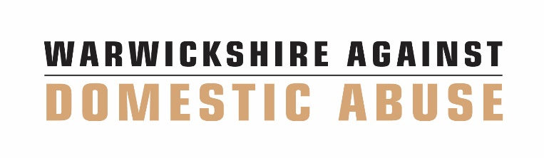
CONFIDENTIALITY DECLARATION: AS READ BY THE MARAC CHAIR.

By accepting MARAC meeting outlook invite or signing this agreement you are agreeing to the terms of the confidentiality statement and the Warwickshire Community Safety Information Sharing Protocol. The confidentiality agreement will be confirmed at the start of the meeting.
The purpose of the MARAC
MARAC is a multi-agency meeting that focuses on the safety of victims/survivors of domestic abuse identified as being at high risk for serious harm or homicide. The purpose of the MARAC is to:
- to share information to increase the safety, health and well-being of victims adults and their children;
- to determine whether the perpetrator poses a significant risk to any particular individual or the general community;
- to construct jointly and implement a risk management plan that provides professional support to all those at risk and that reduces the risk of harm;
- to reduce repeat victimisation;
- to improve agency accountability;
- improve support for staff involved in high risk DV cases; and
- the responsibility to take appropriate actions rests with individual agencies; it is not transferred to the MARAC it is to facilitate, monitor and evaluate effective information sharing to enable appropriate actions to be taken to increase public safety.
Information sharing
Subject to Section 115 Crime and Disorder Act 1998, the General Data Protection Regulations 2016/679, and Data Protection Act 2018 in particular exemptions to GDPR set out at Schedule 2 Part 1 Section 2 Data Protection Act 2018. The information shared is done so on a lawful basis. The lawful basis relied upon is to perform a task in the public interest. The lawful basis for processing special category data is in the substantial public interest for the administration of justice.

Information shared at MARAC must be proportionate, relevant, and necessary to enable an accurate assessment of the risks. A clear distinction should be made between fact and professional opinion.

Each MARAC agency is the data controller for the information which it brings to MARAC.

Attendance at the virtual MARAC meetings
A new dial in link will be circulated prior to each MARAC meeting. When joining the meeting please enter your name and organisation when prompted. If you do not do so you will not be let into the meeting.
During the calls, all attendees working from home must ensure that they attend the meeting in a room where no other people are present. If there are special circumstances, this should be dealt with by the Rep’s manager and raised at Steering Group for approval.

MARAC meetings must not be recorded. Virtual MARAC meetings will be held via Microsoft Teams– this does not allow participants to record the meeting, nor does it upload recordings to cloud. The MARAC Coordinator will hold people in the ‘lobby’ and approve members to meeting manually to ensure only relevant people are on the call. No Guest agencies will be invited, without the consent of the MARAC Chair. Participants working from home must turn off and unplug any smart devices to ensure that MARAC meetings are not accidentally recorded. Should a participant become aware that a device has recorded the meeting, this must be brought to the attention of the Chair immediately.

All normal processes should be abided by, we must have trust that all Reps will continue to act within existing protocols to the best of their ability.

Storage of MARAC documents
All agencies should ensure that all minutes and related documentation are retained in a confidential and appropriately restricted manner. These minutes will aim to reflect that all individuals who are discussed at these meetings should be treated fairly, with respect and without improper discrimination. All work undertaken at the meetings will aim to reflect that all individuals who are discussed at these meetings should be treated fairly, with respect and without improper discrimination. All work undertaken at the meetings will be informed by a commitment to equal opportunities and effective practice issues in relation to age, disability, gender reassignment, marriage and civil partnership, pregnancy, maternity, race, religion or belief, sex, and sexual orientation.

All agencies must ensure home workers have secured all MARAC documents and it is not accessible to any household members. When emailing, only use secure (i.e., CJSM, Egress), or password protect. No passwords or automatic login should be saved on their home computer.

Disclosure of minutes
Information discussed by the agency representatives, within the ambit of this meeting, is strictly confidential and must not be disclosed to the victim, alleged perpetrator or any third parties who have not signed up to the MARAC ISP, without the agreement of the partners of the meeting. The procedure for requesting MARAC minutes is contained in the Warwickshire MARAC Operating Protocol.

All agency representatives understand that the MARAC minutes may need to be shared with another MARAC following the Warwickshire MARAC. This would only be as part of the MARAC-to-MARAC referral in line with the MARAC Operating Protocol. Should any agency representative have any concerns regarding this option for any case, then they should be raised and addressed during the case discussion.

Confidentiality breaches
Any breaches must be immediately raised with MARAC Coordinator and Chair. This is not to place blame or punish, but rather to ensure we are adapting policies as needed in these new times to ensure confidentiality. We will explore how the breach occurred and determine if this is a one-off or systemic issue and respond accordingly. It is vital we remain open, transparent, and reflective with each other during this time while we shape this response plan.

Name | Signature | Organisation Represented | Time signed in and out

Appendix 6 – Integrated Offender Management (IOM) Multi Agency Case Conference Confidentiality Declaration

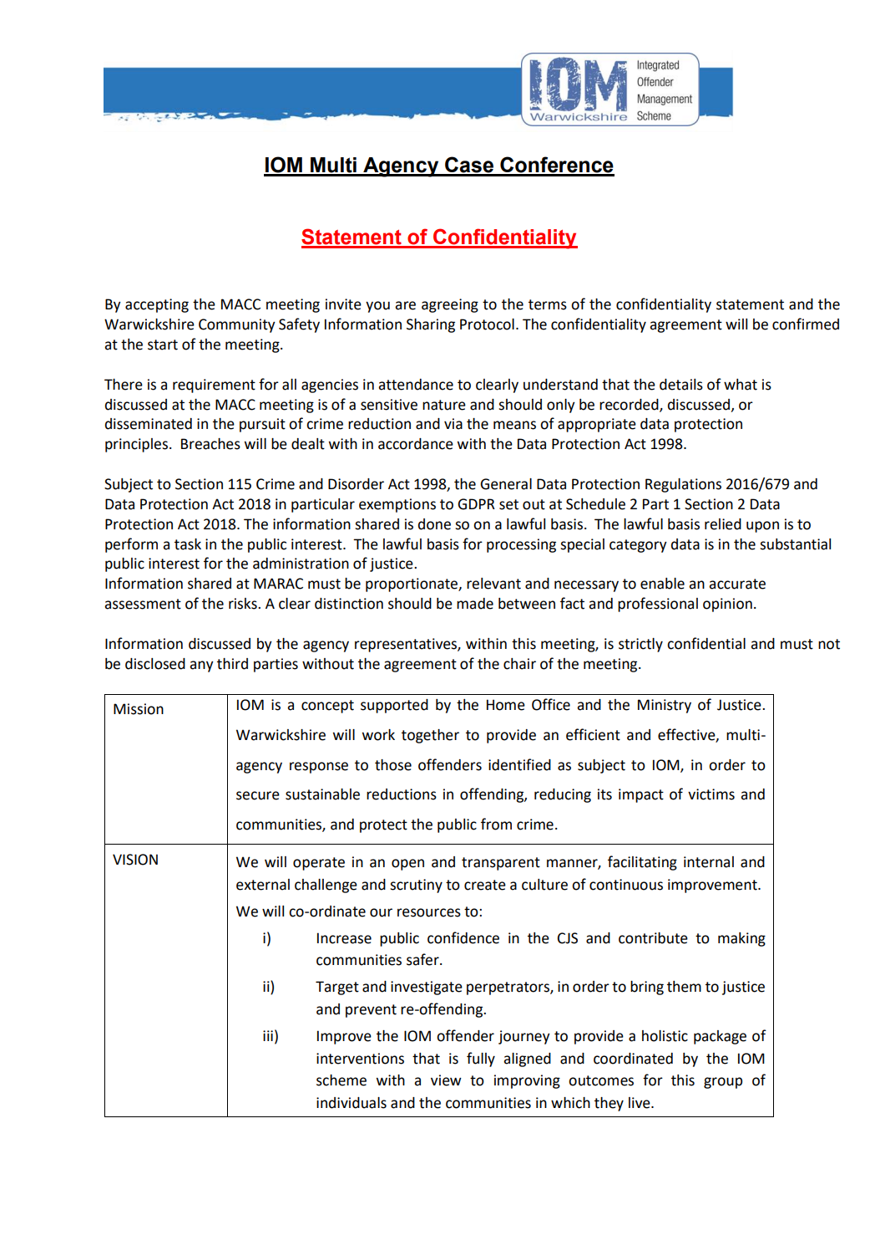
N.B: Not transfer any Shared Personal Data received from another Partner Agency outside the UK
Appendix 7 – Early Help Locality Panels confidentiality declaration.

AREA LOCALITY PANEL
ATTENDANCE LIST
DATE
CONFIDENTIALITY

You have been invited to attend a meeting that includes officers from Warwickshire County Council and other agencies. All agencies are considered to be Data Controllers under the Data Protection Act 1998 (DPA) and are also bound by the common law duty of confidentiality. Attendees are likely to discuss a wide range of issues and exchange personal and sensitive information relating to individuals to identify their service needs and risk of harm. Attendees are requested to share all relevant personal information and should be confident that it would only be used for matters discussed and decisions made within the meeting.

In appending my signature to this statement and attending the meeting and future multi agency meetings, I agree to maintain confidentiality and always abide by the obligations under the Data Protection Act.

Name | Organisation | Email address | Signature

Appendix 8 - Channel Panel confidentiality declaration

CONFIDENTIALITY DECLARATION

Declaration to be signed by persons attending the Warwickshire Multi-Agency Channel Panel meeting dated …………………..

The briefing relates to new cases brought to the panel along with updates from existing cases.

My attention has been drawn to the provisions of the Official Secrets Act 1911, 1920 and 1989, and I am fully aware of the serious consequences which may follow any breach of those provisions.

I understand that the sections of the OSA cover material published in a speech, lecture or radio or television broadcast, or in the Press or in book form. I am aware that I should not divulge any information gained by me as a result of my appointment, to any unauthorised persons, either orally or in writing, without the previous official sanction in writing by the Chief Officer of Police.

I understand also that I am liable to be prosecuted if I publish without official sanction any information I may acquire in the course of my duties as a panel member who is security cleared (unless it has already officially been made public) or retain without official sanction any sketch, plan, model, article, note or official documents which are no longer needed for my duties, and that these provisions apply not only during the period of my membership but also thereafter.

Name | Organisation | Signature | Date

Witness Date and Signature ………………………………………….........................

Appendix 9 - Serious and Organised Crime Joint Action Group
(SOCJAG) Confidentiality Declaration Sign-in Sheet

Name of the meeting: Serious and Organised Crime Joint Action Group (SOCJAG)

Date of meeting:

Chair:

Purpose of the meeting:

The Warwickshire Serious & Organised Crime Joint Action Group [SOCJAG] has been set up to allow law enforcement and partner agencies (Partners) to work together to understand the threat around Serious Organised Crime; to share information and good practice and to identify opportunities for joint working, ensuring all available information and powers are used against the organised crime threat. It also seeks to embed the principles of prevent, prepare, protect, and pursue in accordance with the Government’s Serious Organised Crime Strategy [2018].

As part of the SOCJAG, Partners will work together to tackle Serious Organised Crime to reduce the impact that this has on the local communities, especially the most vulnerable, businesses and the wider economy.
Any personal information or sensitive personal information known as special category data disclosed to you during this meeting has been provided to you in strict confidence and for the purpose of:

- The detection of crime and anti-social behaviour
- The prevention of crime and anti-social behaviour
- The apprehension of an offender for crime or anti-social behaviour
- The prosecution of an offender for crime or anti-social behaviour
subject to Section 115 Crime and Disorder Act 1998, the General Data Protection Regulations 2016/679, and Data Protection Act 2018 in particular exemptions to GDPR set out at Schedule 2 Part 1 Section 2 Data Protection Act 2018.

All signatories agree that:

- The information shared is done so on a lawful basis. The lawful basis relied upon is to perform a task in the public interest. The lawful basis for processing special category data is in the substantial public interest for the administration of justice. Information should only be shared on a need-to-know basis and must not be disclosed to any third party, including the data subject and other staff who do not have direct involvement in the original purpose for which it was disclosed.
Further dissemination will only be permitted where there is a lawful basis to do so.
Where a partner agency requires information for evidential purposes, this cannot be taken directly from meeting discussions and/ or circulated papers. A data protection request (within the Community Safety Information Sharing Protocol - appendices 10 and 11) should be submitted to the data owner to request the specific information in a legally compliant format.

- Data must be stored securely and permanently deleted when it is no longer required for the purpose for which it is provided.

- Any information shared is only valid at the time of provision and should only be used for the purpose as disclosed. It is only disclosed for the specific purpose given at the time of disclosure and should not be used for any other purpose.
- Any information shared will be proportionate and necessary for the purpose for which it is being shared.

- Where possible information shared must be handled and stored in accordance with the Government Security Classifications.

- Where personal information is shared with organisations that do not have access to secure email addresses, it must be encrypted with a password.

- Attendees joining the meeting virtually must ensure that confidentiality is maintained throughout.

- Meetings will not be recorded.

- All persons signing this document are duly authorised to act on behalf of their respective organisation to adhere to the conditions set out.

Please note, by signing this sheet you are agreeing to comply with the requirements of the Safer Warwickshire Partnership Board Community Safety Information Sharing Protocol.

Name | Signature | Organisation Represented

Appendix 10: Request from external agencies to the Police for information.

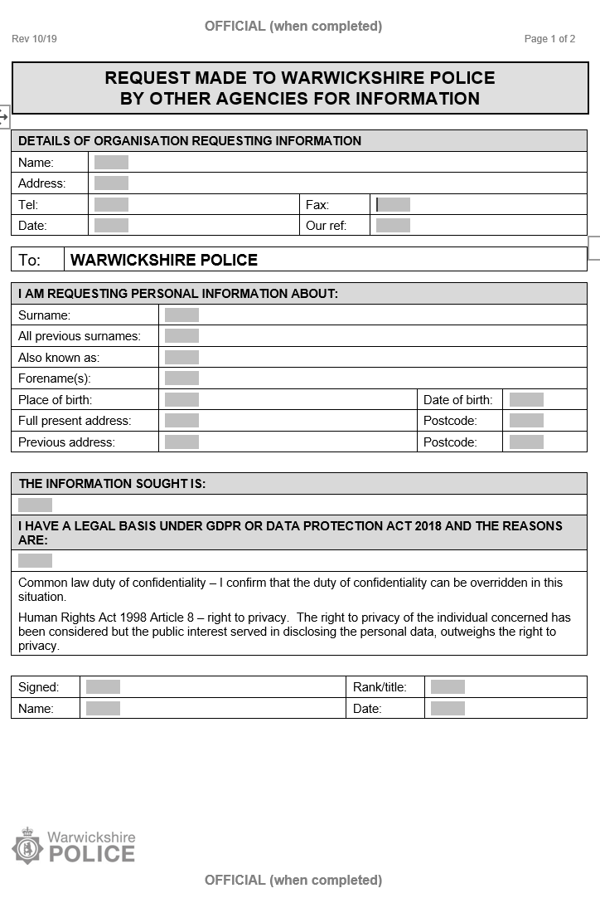

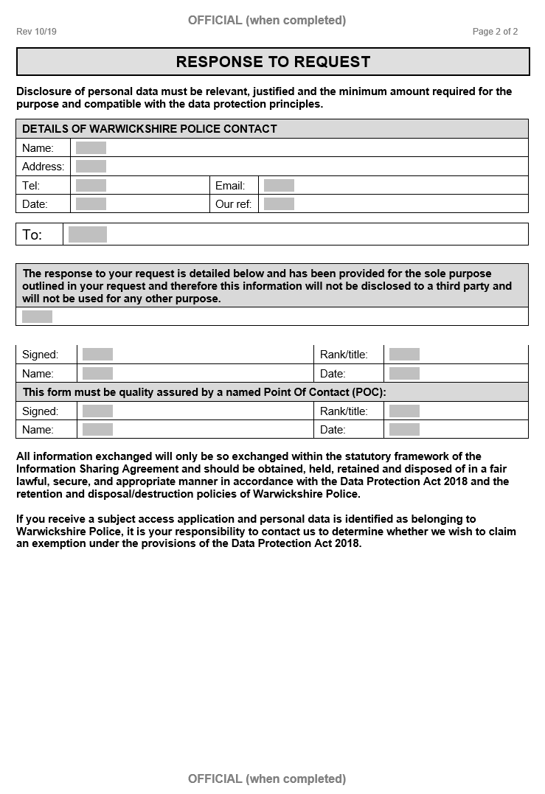

Appendix 11. Request from the Police to external agencies for information

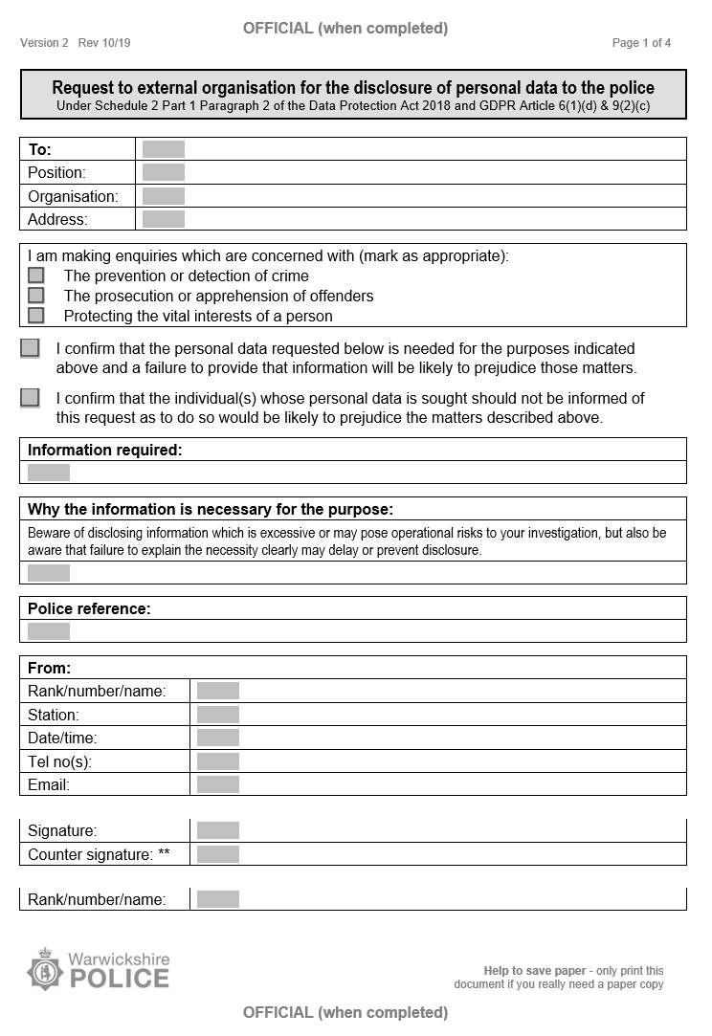

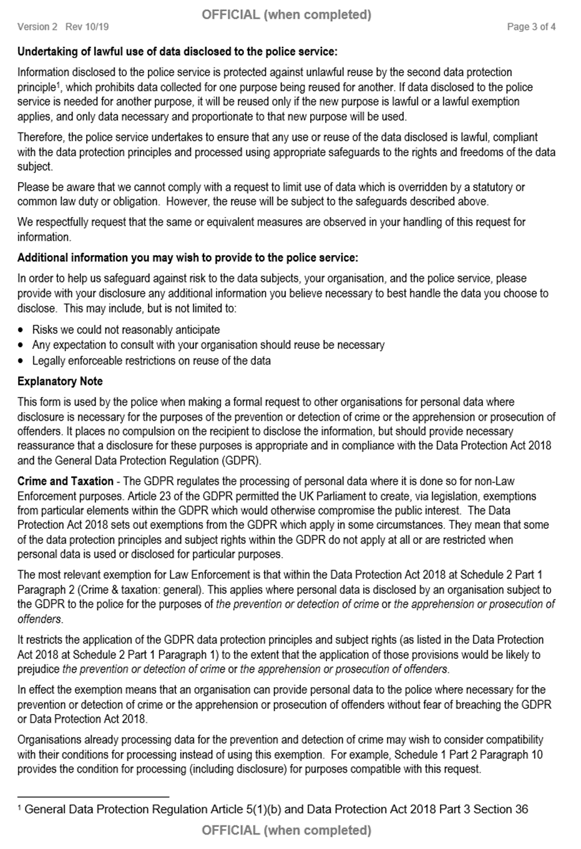

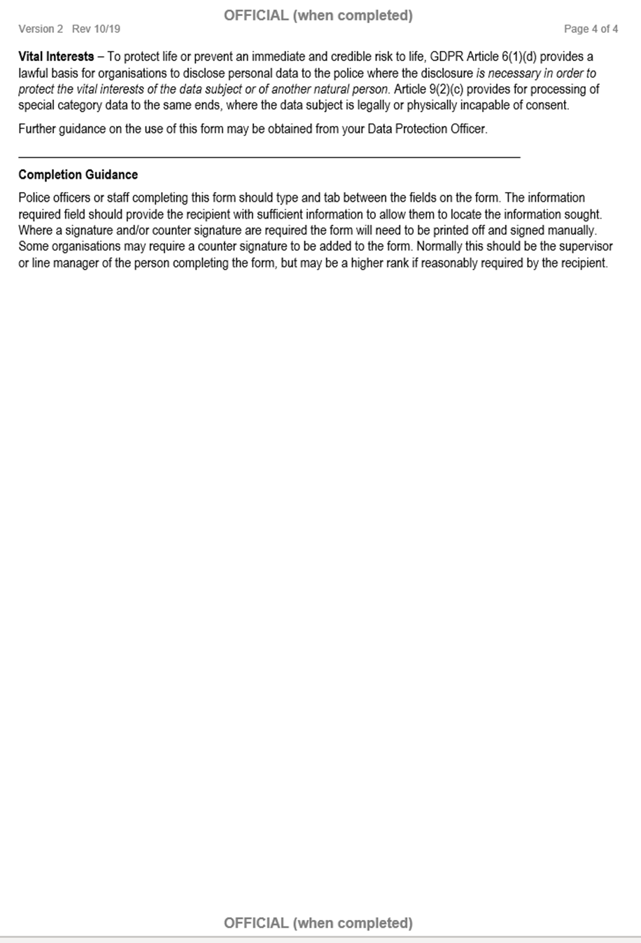

Appendix 12: Safer Warwickshire Partnership Board Signatures

Organisation | Chief Officer signatory and role | Designated Officer(s) | Contact details.
Warwickshire County Council | Monica Fogarty- Chief Executive | Harpreet Rai - PA to the Leader of the Council | harpreetrai@warwickshire.gov.uk
 |  | Shade Agboola - Director of Public Health | shadeagboola@warwickshire.gov.uk
 |  | George Shipman - Service Manager Youth Justice and Child Exploitation | georgeshipman@warwickshire.gov.uk
 |  | Scott Tompkins - Assistant Director Environment Services | scotttompkins@warwickshire.gov.uk
 |  | Becky Hale - Assistant Director People Strategy and Commissioning | beckyhale@warwickshire.gov.uk
 |  | John Coleman- Assistant Director Children and Families | johncoleman@warwickshire.gov.uk
 |  | Pete Sidgwick- Assistant Director Adult Social Care | petesidgwick@warwickshire.gov.uk
 |  | Sally Waldron - Assistant Chief Fire Officer | SallyWaldron@warwickshire.gov.uk
 |  | Chris Baird – (Interim) Assistant Director - Education Services | chrisbaird@warwickshire.gov.uk
North Warwickshire Borough Council | Steve Maxey- Chief Executive | Senior Policy Support Officer, North Warwickshire Borough Council - Julie Taylor | SteveMaxey@NorthWarks.gov.uk  JulieTaylor@NorthWarks.gov.uk
Nuneaton and Bedworth Borough Council | Nicola Topping- Head of Housing and Communities | Abubaker Malek  Supported by Matthew Deaves- Data Protection Officer | Abubaker.malek@nuneatonandbedworth.gov.uk  matthew.deaves@nuneatonandbedworth.gov.uk
Rugby Borough Council | Dan Green- Head of Environment and Public Realm | Dan Green  Supported by Matthew Deaves- Data Protection Officer | Dan.Green@rugby.gov.uk  matthew.deaves@nuneatonandbedworth.gov.uk
Warwick District Council | Marianne Rolfe – Head of Community Protection | Marianne Rolfe  Supported by Gerard Grey- Information Governance manager | Marianne.Rolfe@warwickdc.gov.uk
Stratford-on-Avon District Council | Phill Grafton – Head of Law & Governance and Monitoring Officer | Information Governance manager | phil.grafton@stratford-dc.gov.uk
Warwickshire Police | Debbie Tedds – Chief Constable | Emma McCormick – Legal Services – Information Compliance. | emma.mccormick@warwickshire.police.uk
 |  | Chief Inspectors (CI) – Locality based: Faz Chisty, James Rankin, Steve Davies. | faz.chishty@warwickshire.police.uk  james.rankin@warwickshire.police.uk  steve.davies@warwickshire.police.uk
Probation Service | Andy Wade – Head of Service (Warwickshire) | Alison Heath - Deputy Head of Cluster (Senior Operational Support Manager) | Andy.Wade@justice.gov.uk  Alison.Heath@justice.gov.uk
NHS Coventry and Warwickshire Integrated Care Board (ICB) | Alison Cartwright – Chief Officer for Performance and Delivery | Anita Wilson - Associate Director of Governance and Corporate Affairs/SIRO | anita.wilson5@nhs.net
Equality and Inclusion Partnership (EQuIP) | Junaid Hussain- Chief Executive | Junaid Hussain | junaid@equipequality.org.uk

Appendix 13: Additional Signatures and Designated/ Lead Officers

Organisation | Chief Officer signatory and role | Designated Officer(s) | Contact details
Victim Support Warwickshire | Deborah Miller - Senior Operations Manager | Deborah Miller | deborah.miller@victimsupport.org.uk
Refuge | Mari Edwards – Head of Operations | Rachel Shuter  Hannah Barnes, MARAC Coordinator | rachel_shuter@refuge.org.uk  Hannah_Barnes@refuge.org.uk
Change, Grow, Live (CGL) | Kirsten Lord - Coventry & Warwickshire Services Manager | Kirsten Lord | Kirsten.Lord@cgl.org.uk
Sage Homes | Amanda Mitchell -Partnerships Administrator | Amanda Mitchell - Partnerships Administrator | Amanda.Mitchell@sagehomes.co.uk
All Age Integrated and Targeted Support | Rachel Jackson - Lead Commissioner (Vulnerable People) | Stacey Mann – Commissioner (Vulnerable People) | staceymann@warwickshire.gov.uk
COMPASS | Richard Thomas – Service Manager | Richard Thomas | Richard.Thomas@compass-uk.org
Barnardo’s | Susan Berry - Assistant Director – Children’s Services | Susan Berry | sue.berry@barnardos.org.uk
Bromford Housing | Melanie Goldsby - Neighbourhood Coach | Melanie Goldsby | melanie.goldsby@bromford.co.uk
Stratford-upon-Avon Street Pastors | Maureen Lynda Green - Coordinator | Maureen Lynda Green | stratforduponavon@streetpastors.org.uk
Leamington Night Shelter | Margaret Moore – Coordinator | Margaret Moore | margaretmoore401@btinternet.com
Warwickshire Search and Rescue | Ian Malins – Chair | Ian Malins | chair@warksar.org.uk
Warwickshire Counselling Centre | Julie Mitchelson – Assistant Manager (Children & Young People) / Administrator | Julie Mitchelson | julie.mitchelson@sycamorecounselling.org.uk
Helping Hands Community Project | Alice Webber – Operations Manager | Alice Webber / Lianne Kirkman | operations@helpinghandscharity.org.uk
Salvation Army – Way Ahead Project | Yvonne Mckinnon – Project Manager | Yvonne Mckinnon | yvonne.mckinnon@salvationarmy.org.uk
Midland Heart (Housing Association) | Vicki Brownhill - Head of Housing Management | Sue Lamb | vicki.brownhill@midlandheart.org.uk sue.lamb@midlandheart.org.uk
Warwickshire Rural Housing Association | Philippa Osborne - Housing and Income Team Leader | Philippa Osborne | philippa.osborne@midlandsrural.org.uk
HMP Featherstone | Warren Sullivan - Governor | Rachael Lindop | rachael.lindop@justice.gov.uk
Doorway | Carol Gallagher - CEO | Shona Mellor | info@doorway.org.uk  shona.mellor@doorway.org.uk
Futures Unlocked | Philip Jones - Operations Manager | Philip Jones | admin@futuresunlocked.org philip.jones@futuresunlocked.org
Stonewater | Catherine Preece – Area Manager | Catherine Preece | catherine.preece@stonewater.org
Stratforward BID Ltd | Diane Mansell – BID Director | Diane Mansell | diane@stratforward.co.uk
Coventry Cyrenians | Richard Tyson – Senior Housing Support Worker | Richard Tyson | richard.tyson@coventrycyrenians.org
Coventry & Warwickshire NHS Partnership Trust (South Warwickshire Recovery Team) | Laura Sale - Team Manager | Laura Sale | laura.sale@covwarkpt.nhs.uk
Warwickshire Retail Crime Initiative | Derek Bradley and P.J. Seal – WRCI Administrators | Derek Bradley  P. J. Seal | wrcinorth@wrci.org.uk  wrcisouth@wrci.org.uk
P3 Social Inclusion Charity | Esther Barrett – Head of Support and Community Services | Henry Webster | henry.webster@p3charity.org
South Warwickshire University NHS Foundation Trust | Charles Ashton – Medical Director | Charles Ashton | charles.ashton@swft.nhs.uk
Orbit Group | Andrew Meyer - Head of Tenancy Services | Andrew Meyer | andrew.meyer@orbit.org.uk
Platform Housing Group | Catherine Cole – Assistant Director | Jon Elger | jon.elger@platformhg.com
RoSA (rape or sexual abuse support) | Julie Bettelley - CEO | Julie Bettelley | julie.bettelley@rosasupport.org
Safeline | Neil Henderson - CEO | Neil Henderson | neil@safeline.org.uk
Rugby First | Luke Phillips – Control Room Manager/BID Manager | Luke Phillips | luke@rugbyfirst.org
Bradby Club | Rebecca Thomas – Youth Worker/Designated Safeguarding Lead | John Robertson | john@bradby.org.uk
Get-to CIC | Lloyd Robinson- Managing Director | Lloyd Robinson | l.robinson@get-to.co.uk
Spring Housing | Raj Shergill - Director of Housing & Customer Services | Raj Shergill | rajbir@springhousing.org.uk
Walsall Housing Group | Sofia Ali - Housing Solicitor and Data Protection Officer | Sofia Ali | sofia.ali@whgrp.co.uk
EOS Ex Offender Support CIC | Christopher Leslie - Director | Christopher Leslie | chris@eoscic.com
Family Intervention Counselling Service | Donna Hodge - Director and Trainee Forensic Psychologist | Donna Hodge | admin@interventionservices.co.uk
Myspace Housing | Rachael Reeves - Housing Manager, (Midlands) | Rachael Reeves | rachael.reeves@myspacehousing.org
Mediation and Community Support service | Judith Halliday - referrer to councils re ASB and Mediation | Judith Halliday | macs1@btconnect.com
Citizen Housing | Kevin Rodgers - Chief Executive | Becky Springs | TBA
West Midlands Anti-Slavery Network | Nigel Oseman -Independent Modern Slavery Advocate | Nigel Oseman | nigel.oseman@westmidlandsantislavery.org
Equation | Marie Bower | Head of Service (Survivors and Perpetrators) | Marie Bower | marie@equation.org.uk
Youth Escape Arts  Escapearts.org | Sarah Cowley-Catchpole, Youth Work Coordinator | Sarah Cowley-Catchpole | youth@escapearts.org.uk

Agreed for use in Community Impact Operational Groups, Vulnerability meetings, Partnership Problem Solving meetings, Domestic Homicide Review Panels, Hate Crime meetings, Stratford District ASB and Case Management meetings, Warwick District ASB and Case Management meetings, Rugby Borough ASB Youth and Victim Case Management meetings, Nuneaton and Bedworth Borough ASB meetings and North Warwickshire Borough ASB meetings.
The Police and Crime Commissioner is also a member of the Safer Warwickshire Partnership Board. He is not included as a signatory as his team are not involved in partnership meetings where the level of personal information covered within the protocol is discussed.

